Status of all pods before master removal
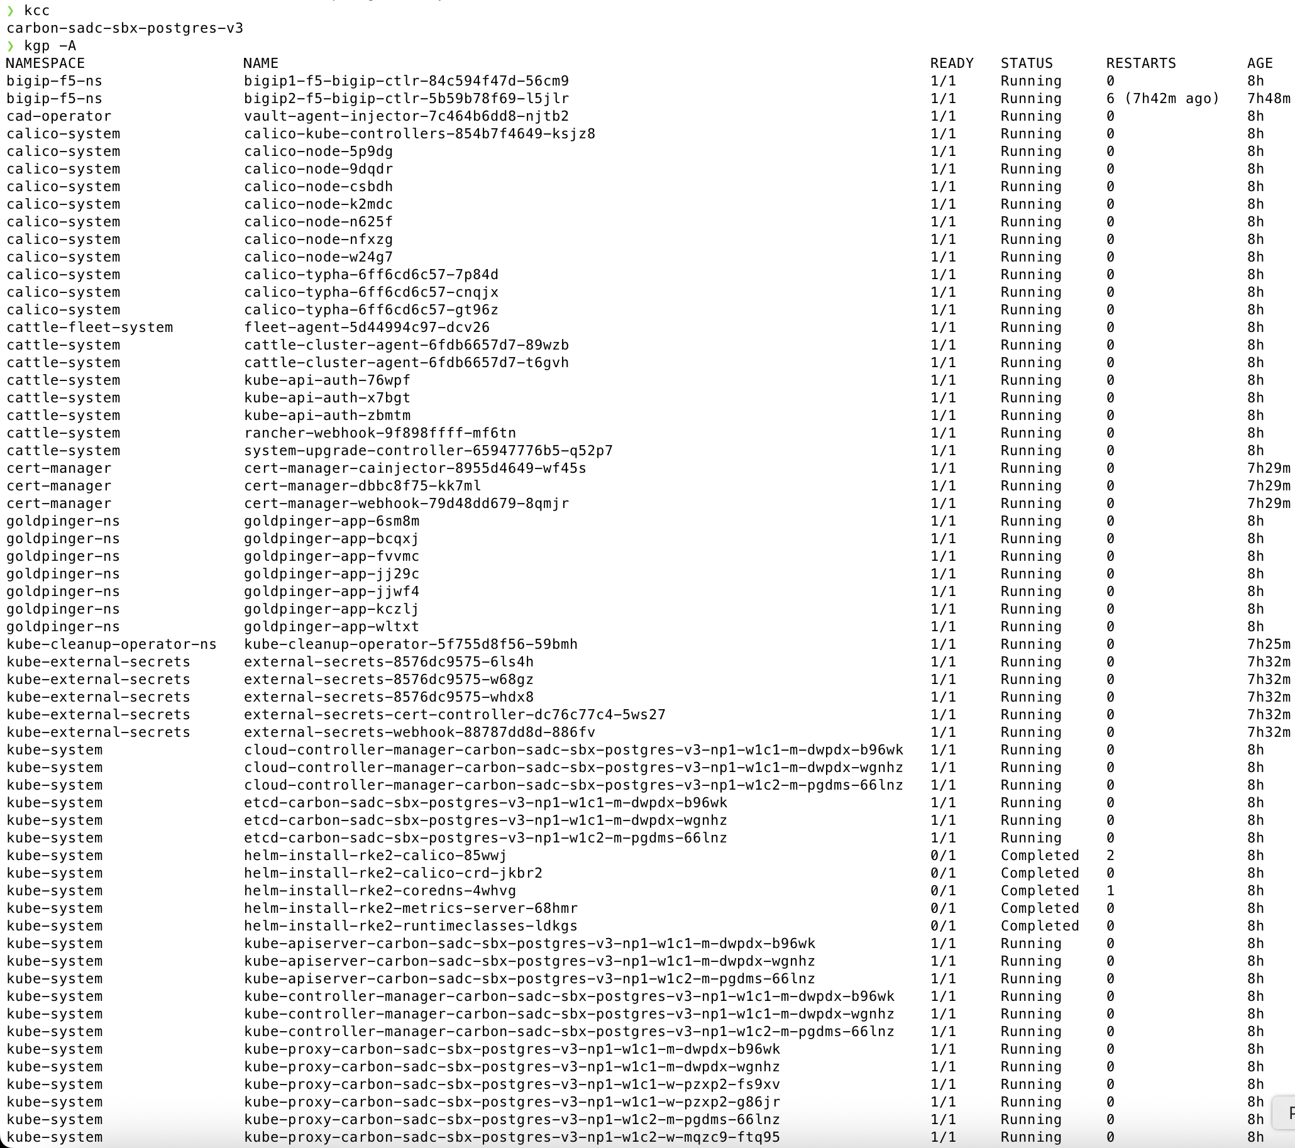

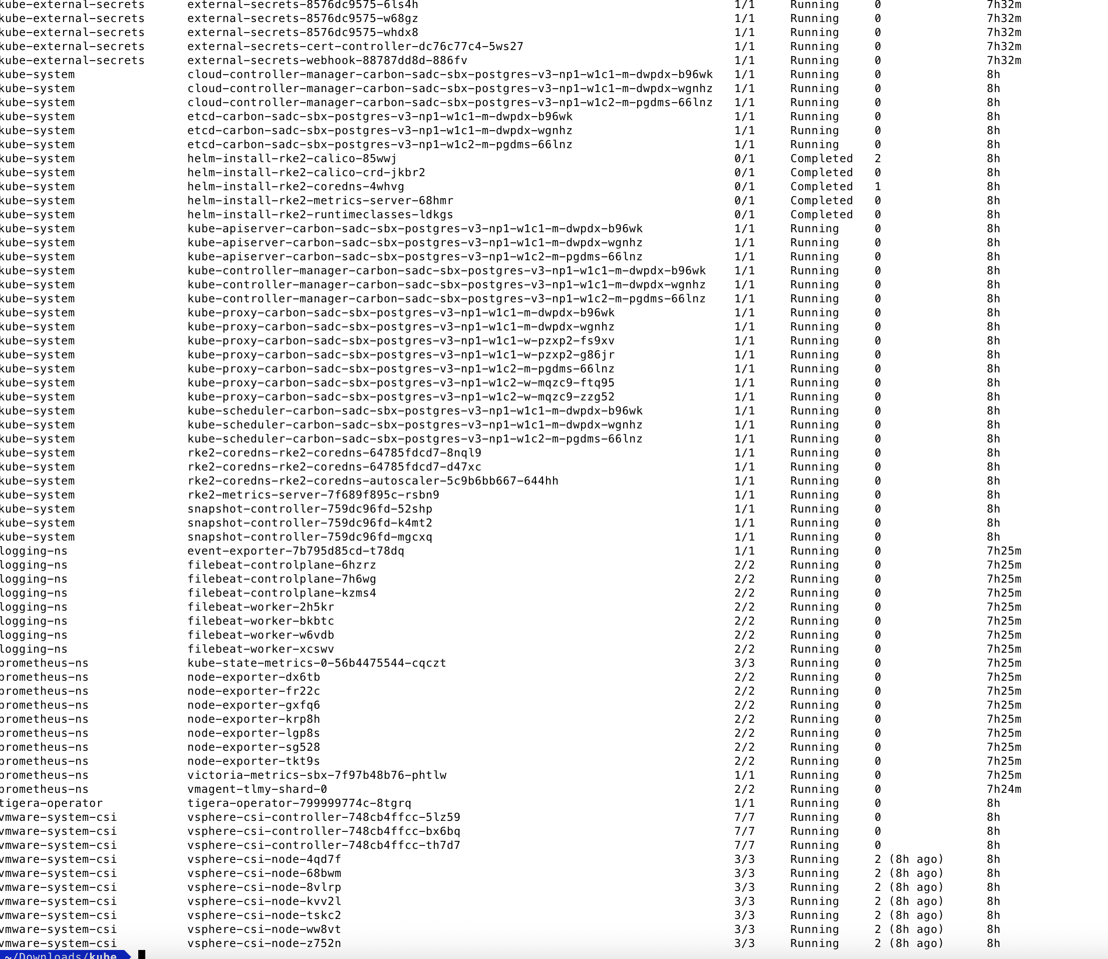

Status of PVs within the cluster

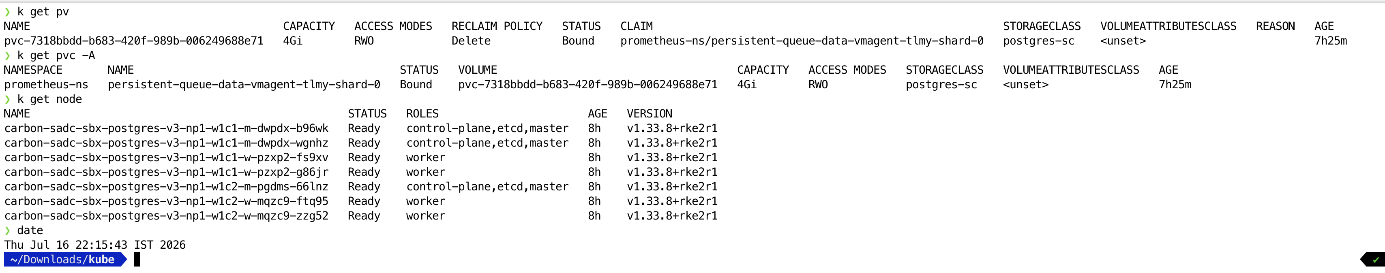

Rancher UI S3 snapshot snippet
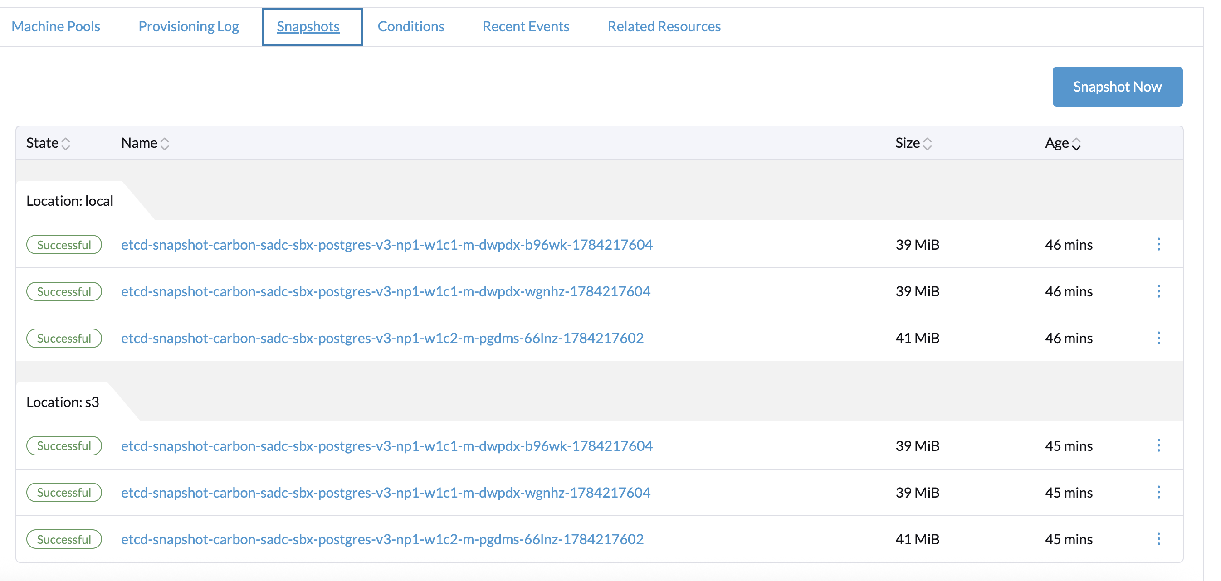

S3 snapshot snippet
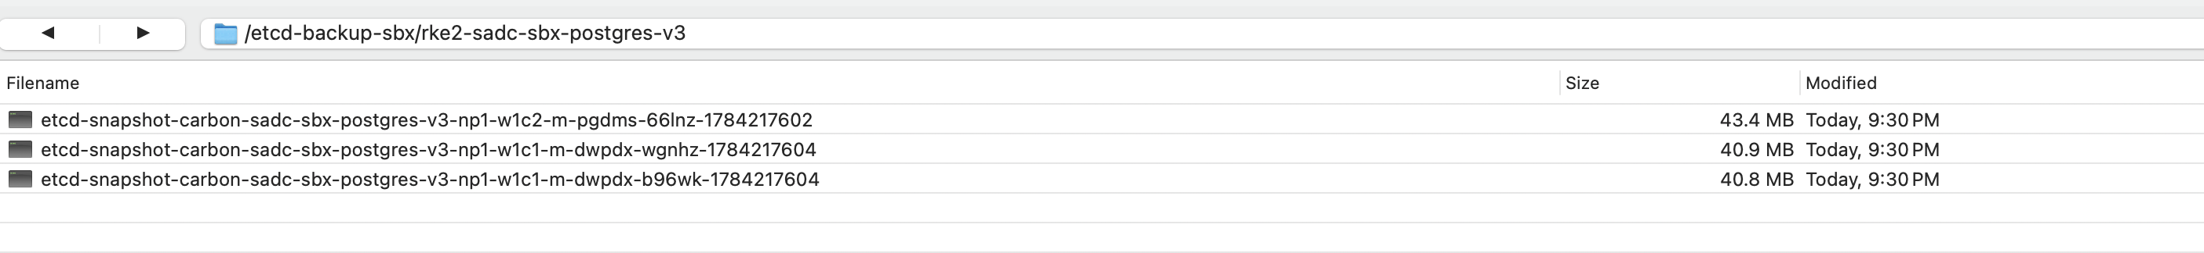

Select all 3 master vms in rancher UI and triggered scaled down
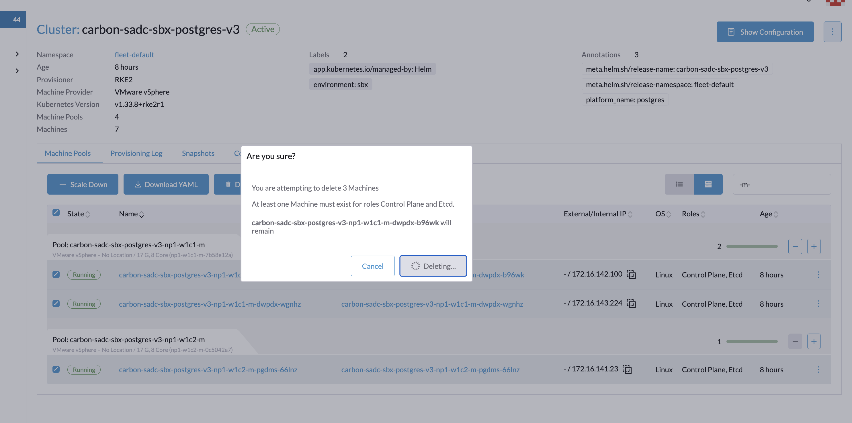

Deletion Triggered
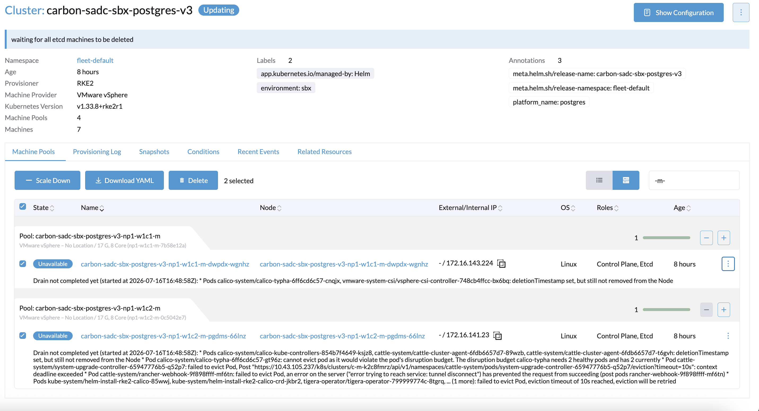

All master vms removed from the cluster

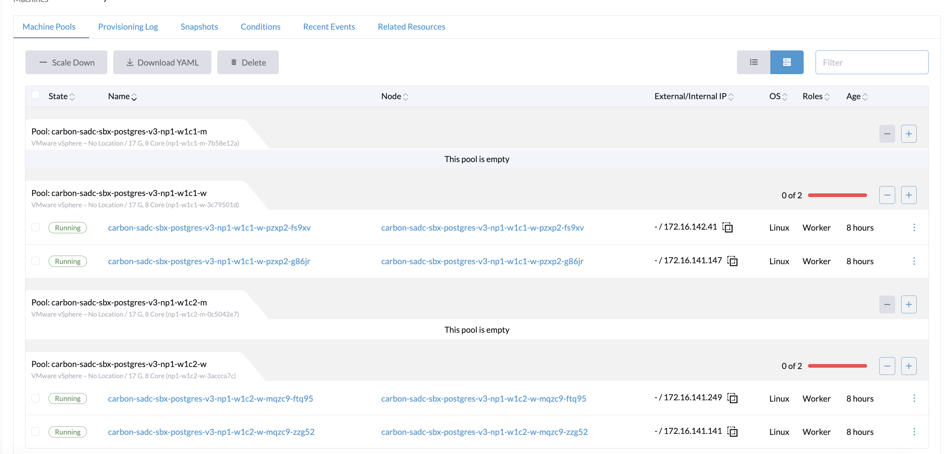

Edited Cluster under Edit-> Config and added new vm by selecting all options etcd, controlplane, and worker
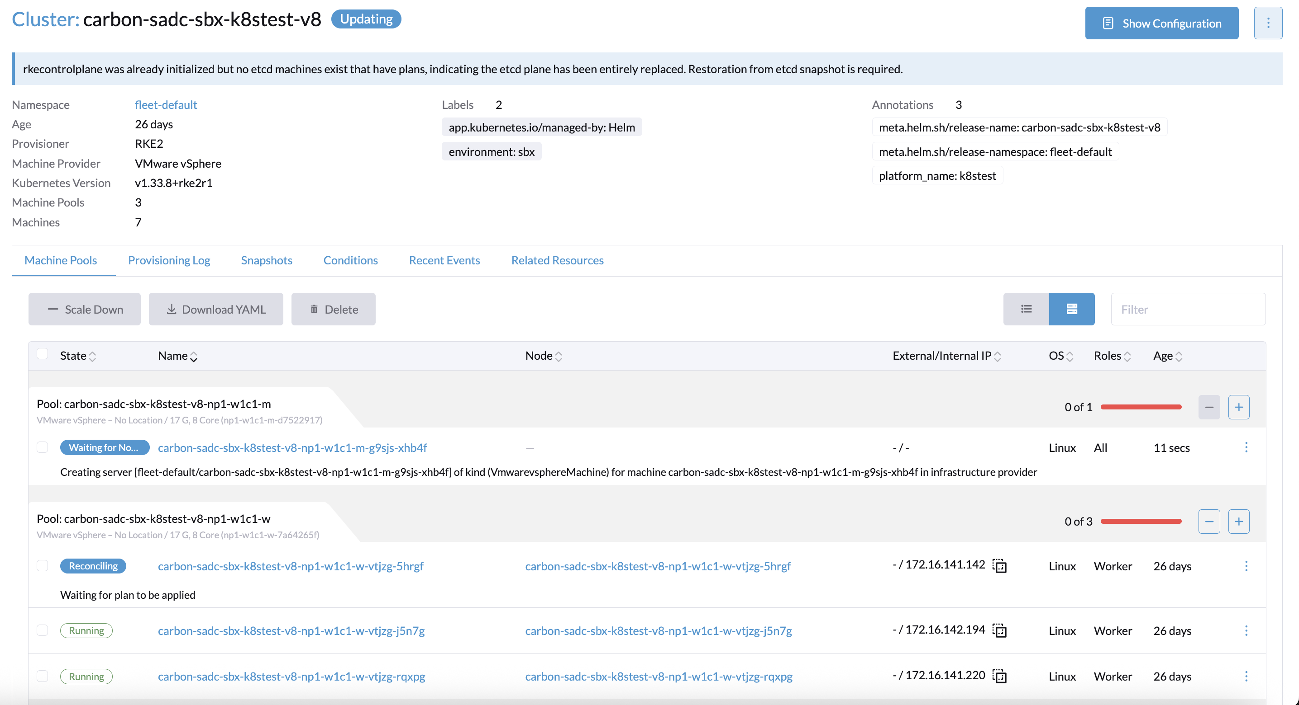

Edit Cluster-> Increased node -> Selected ALL

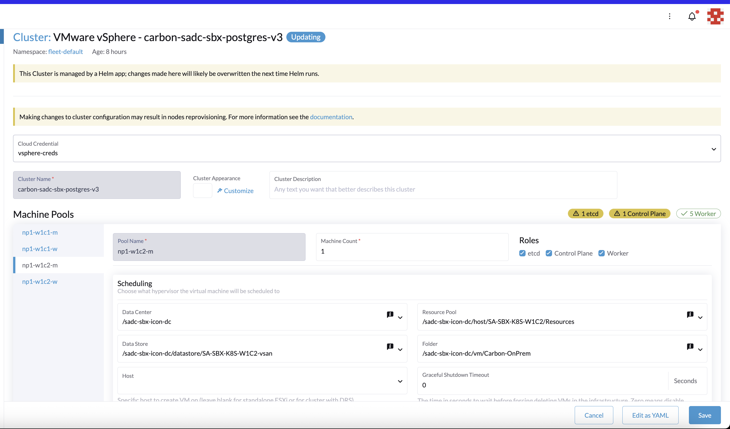

Added new VM
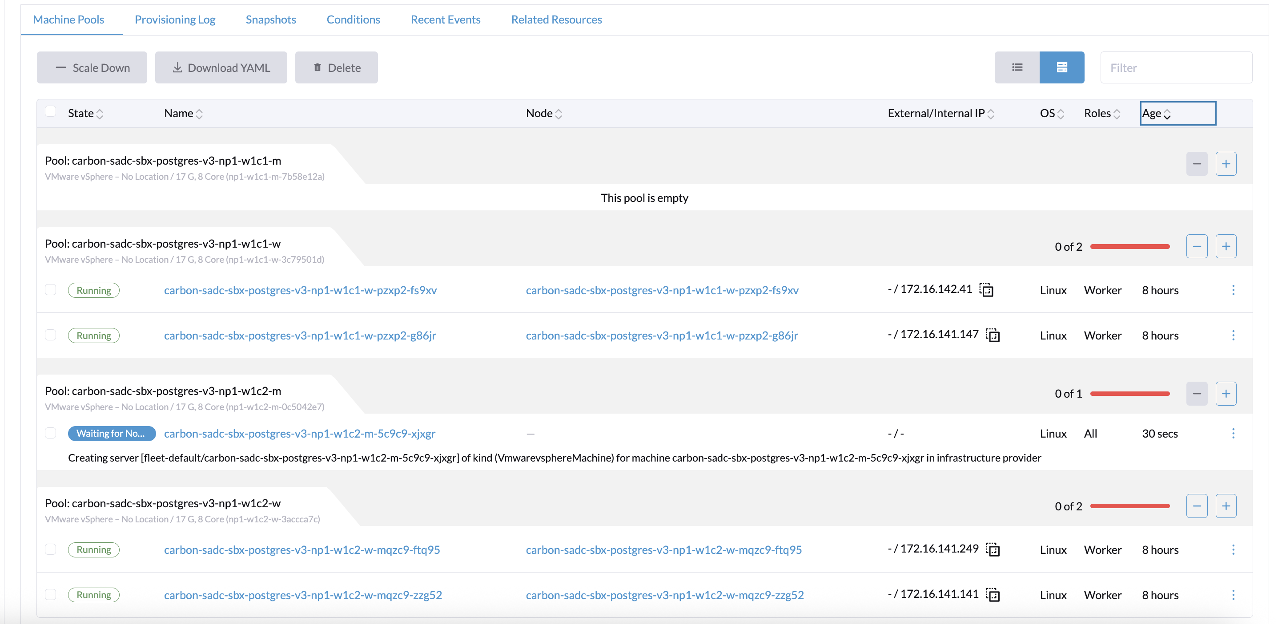

As per docs, create snapshot folder within the new vm

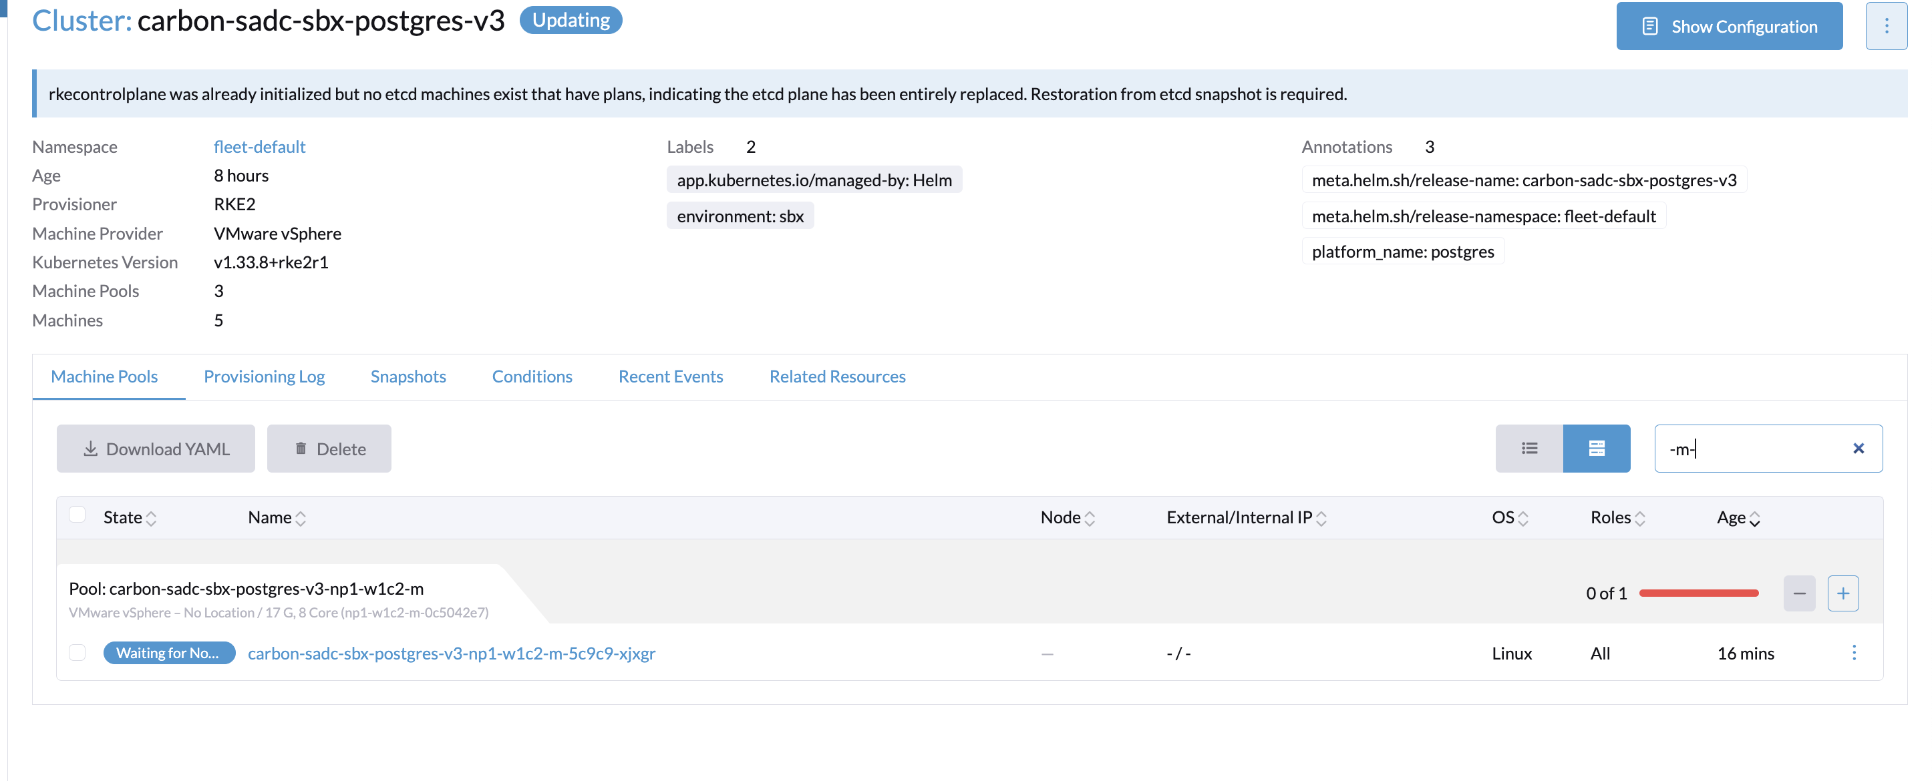

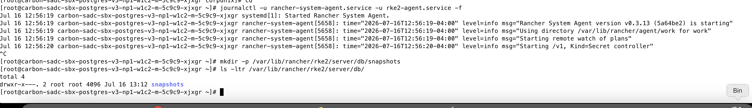

Triggered etcd restore
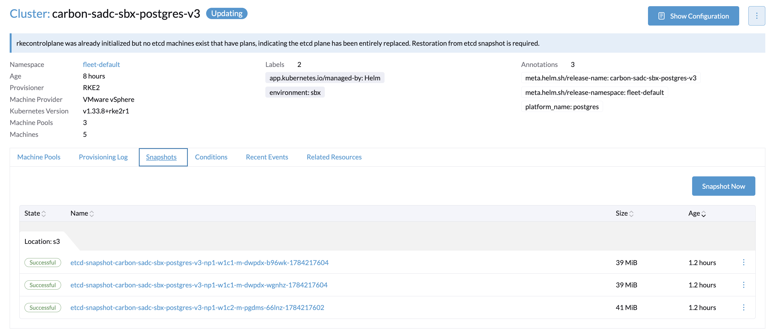

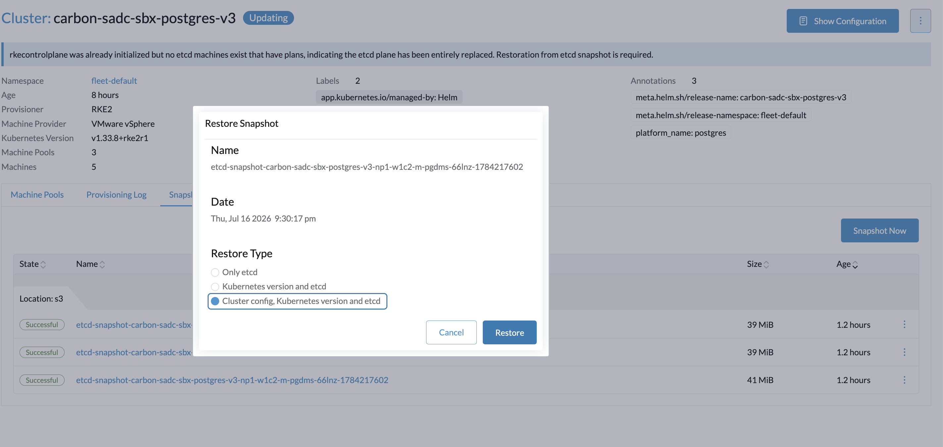

Auto stops all services in workers
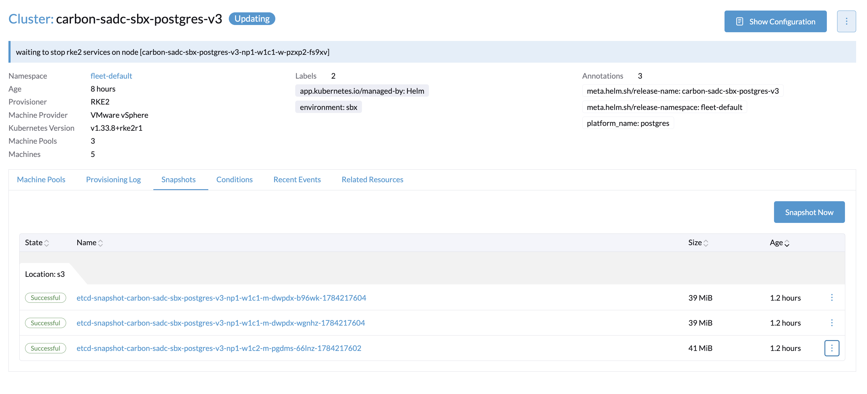

Etcd restore started
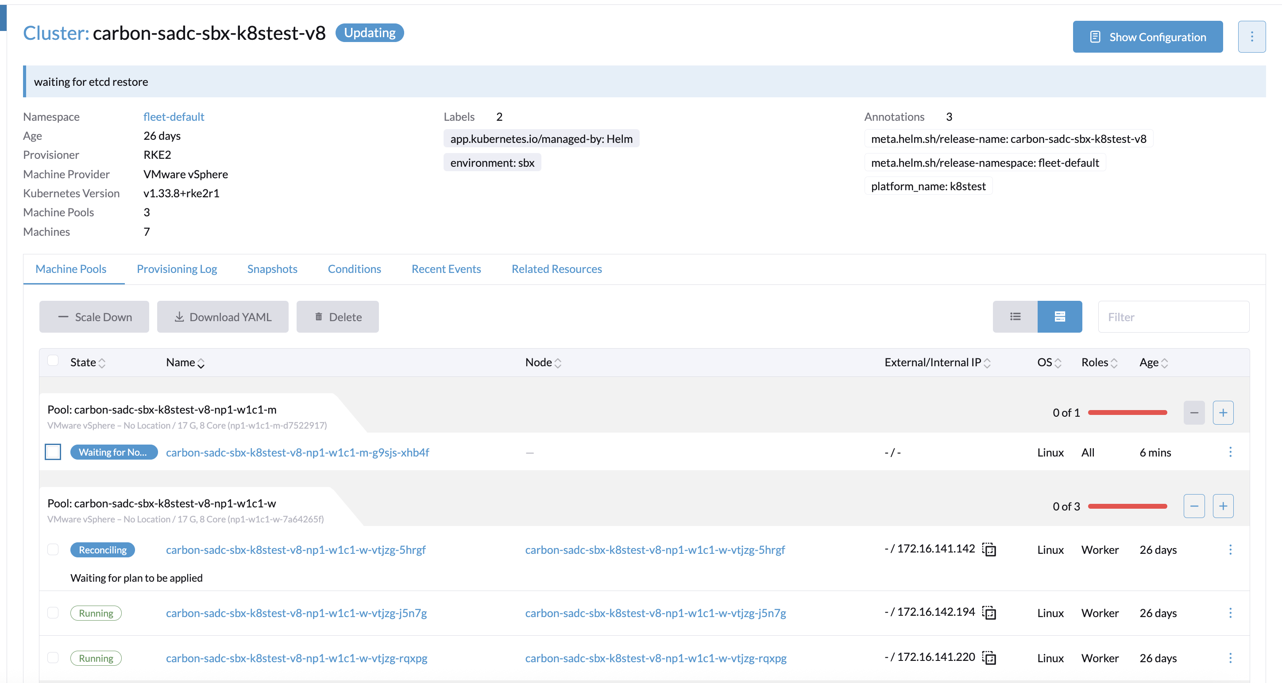

New VM Ended as below and tried to check the logs further

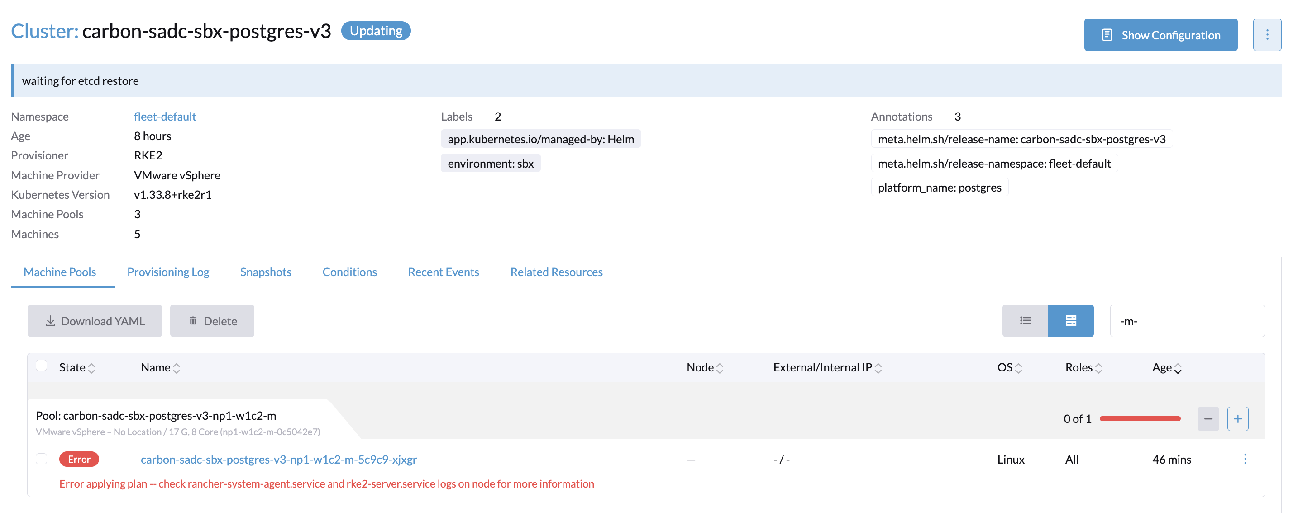

Received checksum error
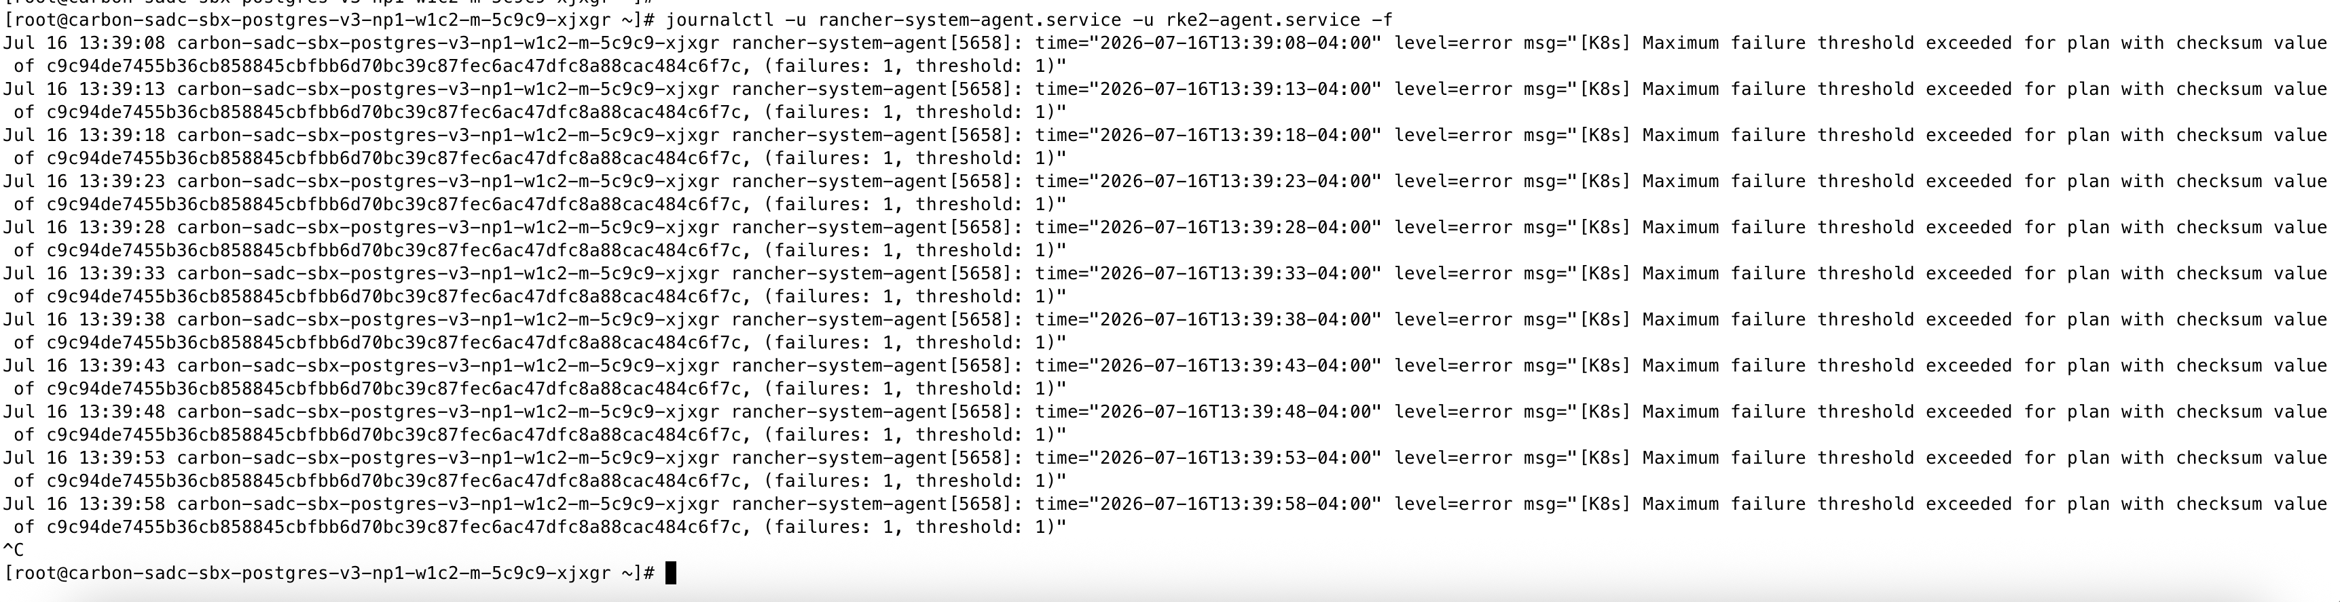

To fix checksum i had to update the machine-plan secret in local cluster as mentioned in following docs - https://support.scc.suse.com/s/kb/rancher-system-agent-maximum-failure-threshold-exceeded-for-plan?language=en_US
Machine plan exist in local cluster → Update the machine-plan of the new VM failure-count field from MQo=, replace the value with MA==.

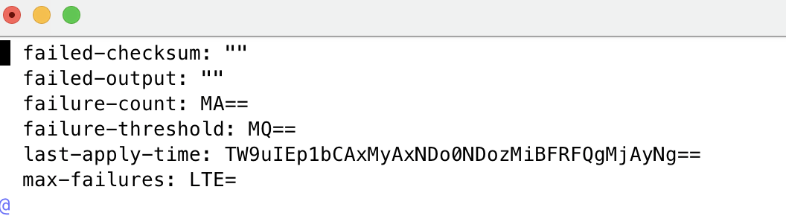

FINALLY CLUSTER IS AT THIS STATE AND WHEN I CLUSTER AND RUN KUBECTL COMMANDS IT SHOWS AS NEW CLUSTER

